General Suggestions r.e. Shooting with the Holga (you may have to do a Ctrl-click to open the links)
The Holga has no controls, therefore:

Embrace not being in control
Use your right brain; be spontaneous
Don’t focus on how far to turn the knob; turn it any old amount, you will learn what works for you
Know that you need to remove the plastic mask piece within the camera
Light leaks easily solved (tape those 2 interior screw holes)
Try shooting from the hip (it is fun!)
I recommend shooting very fast
I recommend shooting one subject per roll; think of a roll as a single image
Don’t worry about how many shots to a roll… just shoot off the end of the roll
Mostly stick to sunny days and a high ISO of film
You can make up for less desirable circumstances with special processing (pushing) of the film and always
working the image in Photoshop; save the left brain for post-production

Suggested Vendors/Products
To buy the Holga camera itself: B&H Photo or Freestyle Photo. You want the 120N… and black masking tape.
Film Purchasing: Adorama or B&H, 120 film, high ISO, I mostly used Kodak Portra 800. Film is now expensive.
Film Processing: LTI Lab, 34 E 30th St (near Park Ave), 212-685-6871 or another option: thedarkroom.com.
>>> Ask for processing only, "DO NOT CUT" <<< You do not want them deciding where to cut the film.

A video on how to load, shoot, and unload the film:: Youtube: How to Load, Shoot, & Unload Holga Camera

Scanning: If you must use a lab for this, they will have to cut the negative... try to make the cut pieces as long as possible. A flatbed scanner will give you more length than a film scanner.

To buy a flatbed scanner, you want one with a light in the lid (transparency unit), and ideally a large scanning area, 17" long in the longer direction. Epson Expression 12000XL is one (not cheap); you may be able to get one used (note that sometimes you have to pay extra for the transparency unit). A cheap one to start with (which can only do 8.5" of negative at a time (so you'd need to cut the film and do 3 splices instead of 1): Epson Perfection V600.

Printing: To print on paper at home, you would need to print lengthwise using roll paper. I preferred digital C-prints made by a lab. Chromira is one of the types of machines that prints digital C-prints. Because most use 30" wide roll paper, I made my standard prints 30" wide. I would gang up 5 or 6 images in one file and have them printed at once (and cut them apart later). A reasonably priced lab for this is Print Space,19 W 21st St.. The Chromira machine prints any width up to 30” and any length up to 275 feet. Note that these are wet-processed prints like would be made in a color darkroom. Many labs have such printers.

Matting & Framing... will always be custom. Mostly I have used framedestination.com or webpictureframes.com.
For bulk mats: MatCutter.com.

Note that I ultimately chose to make my images about ½ the length of a negative, which is an aspect ratio of 1:7. So that means if I were to print an image 2 feet high, the length would be 14 feet. That also means when presenting on a computer... if the image is 700 pixels wide, the height is only 100 pixels. So you will often run into the fact that in many forms of presentation, the image will be tiny. Another thing to note: scanning the negatives at 16 bit (1600 dpi), starting with a spliced together full roll, the file size is over 1 gig. The final file of ½ of a roll at 8 bit, flattened is more like 250MB. So files are big (as I worked anyway).

Note that there is scads of info on the Holga online. And you might want to follow @thedailyholga on Instagram.

Website/Social: susanbowenphoto.com . instagram.com/susanbowenfoto . vero.co/susanbowenphoto
Email: susanbowenphoto@gmail.com or susan@susanbowenphoto.com
Mailing List: tinyurl.com/BowenSubscribe. I have an upcoming exhibit in December at Soho Photo Gallery

So you have this list too…

A Holga is:

- A film camera
- A camera made of plastic (so it is very lightweight)
- A rangefinder camera (you aren’t looking thru the lens)
- It has no controls (1 f-stop, 1 shutter speed: f-8, 1/100)
- It uses medium-format film (120 film), 2-¼” high, which means you can print big
- You must remove the interior plastic piece/mask for the overlapping to work (see below)
- It is known for light-leaks, but easy to avoid (taping those 2 screw holes, see below)
- Overlaps happen by not advancing film all the way
- It does have a hot-shoe so flash is an option
- It does have a bulb mode for long exposures
- It is made in China, originally for locals, but took off globally
- It is a cult camera

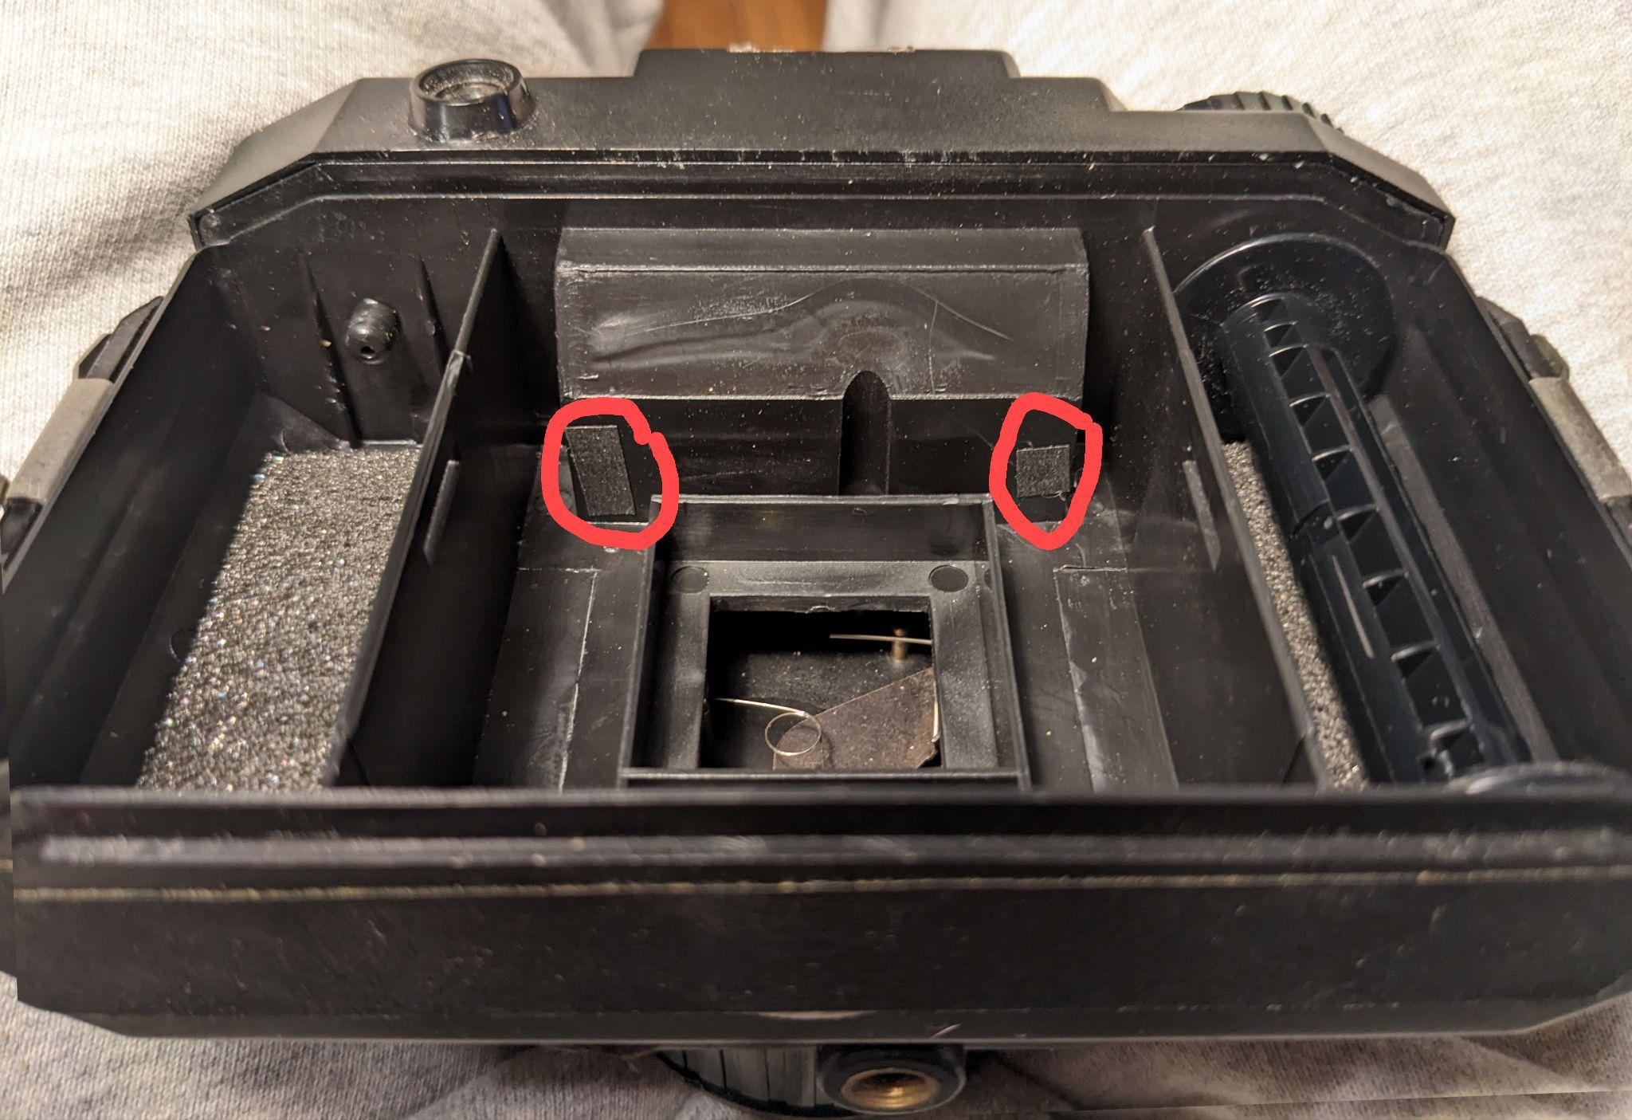
Above are the holes you have to tape; don’t forget to remove (throw out) this plastic piece shown below:
